
Symbiosis Institute of Technology, Pune
Faculty of Engineering
CSE- Academic Year 2025-26
Compiler Construction Lab Batch 2022-26
Lab Assignment No: - 7
Name of Student | Vaishnawi Kalgaonkar
PRN No. | 22070122244
Batch | 2022-26
Class | CSE-C3
Academic Year & Semester | 2025-26  VII
Date of Performance | 25/09/25
Title of Assignment | Postfix Expression Evaluation.
Practice Questions | - YACC program for Postfix Expression Evaluation.  - YACC program for Conversion of Infix to Postfix expression.
Source Code | Scanner.l  %{  #include "parser.tab.h"  #include <stdlib.h>  %}  %%  [0-9]+(\.[0-9]+)? { yylval.val = atof(yytext); return NUMBER; }  [+\-*/()] { return yytext[0]; }  [ \t\n]+ ; // ignore whitespace  %%  int yywrap() { return 1; }  parser.y  %{  #include <stdio.h>  #include <stdlib.h>  void yyerror(const char *s);  int yylex();  %}  %union {  double val;  }  %token <val> NUMBER  %type <val> expr  %left '+' '-'  %left '*' '/'  %%  expr:  expr '+' expr { $$ = $1 + $3; printf("+ "); }  | expr '-' expr { $$ = $1 - $3; printf("- "); }  | expr '*' expr { $$ = $1 * $3; printf("* "); }  | expr '/' expr { $$ = $1 / $3; printf("/ "); }  | '(' expr ')' { $$ = $2; }  | NUMBER { $$ = $1; printf("%.2f ", $1); }  ;  %%  void yyerror(const char *s) {  fprintf(stderr, "Error: %s\n", s);  }  int main() {  printf("Enter infix expression:\n");  yyparse();  printf("\n");  return 0;  }
Output Screenshot | 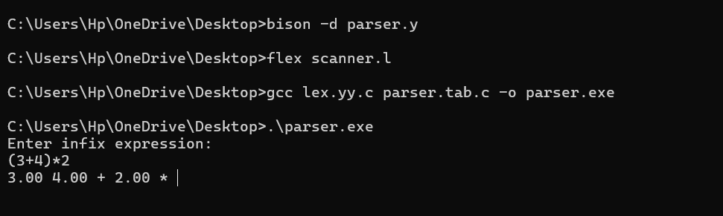  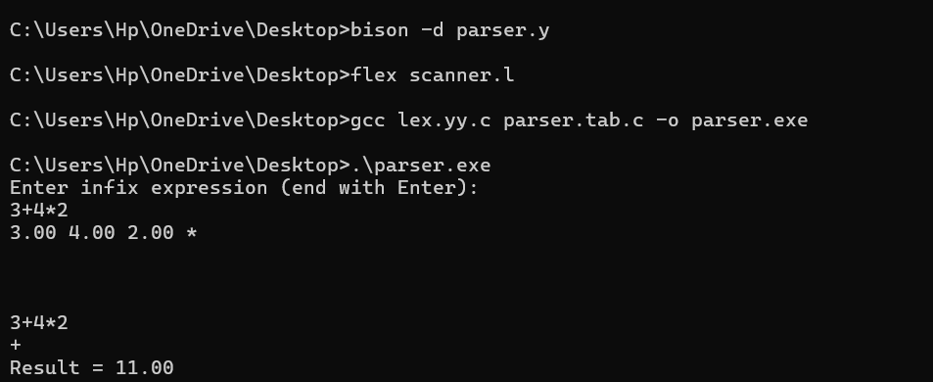

Post lab questions | 1.YACC program for evaluating postfix expressions containing decimal numbers.  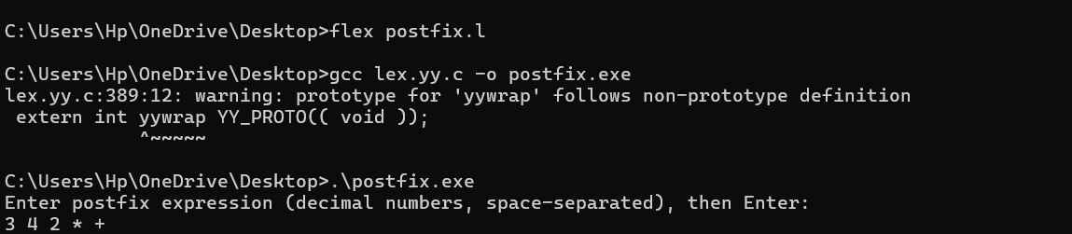
Conclusion | The experiment successfully demonstrated the evaluation of postfix expressions using a stack, showing how numbers and operators are processed sequentially to compute the final result.

